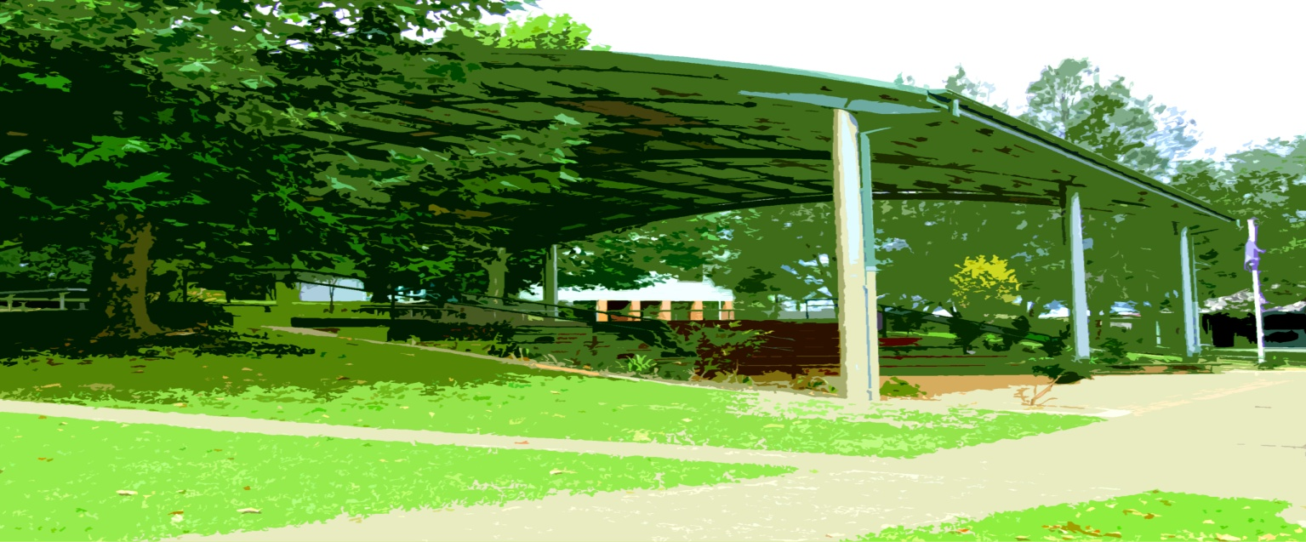

**Principal’s Report**

**The official opening of the Sculpture Trail last Friday, led by Mr Hamish Malcolm, was a celebration of a lot of creative and physical work by the community. There were a number of representatives from the Council and community including the Deputy Mayor, Cr Sally Townley. The sculptures have enriched our school visually and emotionally as well as providing inspiration to students through the messages embedded within and as examples of artwork. Hamish is a very humble artist and we cannot thank him enough for his efforts.**

**The school was visited by the Barrenjoey High School band on Monday this week. The students from Sydney had a workshop with our Big Band. After recess the two bands combined for a piece and then the BJHS band entertained us with performances from their concert band, jazz band, individual singers and their rock band which played and sang a soothing Wolf Mother song for us, much to the delight of our senior students.**

**This Friday the full band will be playing on assembly and Mayor, Denise Knight, will be in attendance. Following the assembly Cr Knight will be viewing the sculpture trail. Parents are welcome to join us for the wander.**

An Oral Health Day has been organised for 3 December at Toormina PS and some of our students will be attending. Notes have been sent to the students involved.

The two swimming programs have been a great success again this year. Miss Hague and the kindergarten teachers orgainsed the two programs. Thank you to Sawtell Swim Centre and to the parents who helped small groups of students with their lessons. It is essential, living where we do, that students learn to swim.

It is a very busy time of year for our school community. Please keep viewing the calendar in the current newsletter as dates and times can change. If for some reason a newsletter doesn’t reach home please go to the Sawtell Public School website and access a copy there.

Reports are close to completion and will be ready for sending home on 12 December.

The smell of mint was in the air this week as an oral health technician presented lessons on dental health for our Year K, 1, 2 and 6 students.

This Wednesday is a very exciting day for our Yr 6 students as they have their first official day at Toormina High School.

They will be placed in their classes for 2015 and begin to become familiar with the routine of high school life.

Next Tuesday 9 December is our Parent Helper morning tea at 10:55 in the new hall. Our school is successful because of the high level of goodwill. The morning tea is just a small way in which we can thank all of the parents and community members who support our school in a thousand different ways. Please come.

This week our choir is filming their audition to be sent to Sydney in the hope that they will be invited to sing at the Opera House next year. The dedication displayed by the students, Mrs Pollack and Mr K is inspirational, with both students and Mrs Pollack giving up many lunchtimes to reach their goal. ***We wish them luck***.

**Performing Arts**

*Thursday 4 December* at 12:45 the string ensemble and choir will be performing at the Sawtell RSL Club for the Waratah Gadabouts charity group.

*Friday 5 December* the Big Band will be performing at assembly. Mayor Denise Knight will be attending. Cr Knight is a great supporter of the arts in our Council area and an ex-parent of our school.

*Monday 8 December* the Big Band, string ensemble and choir will be performing at Presentation Night. Band members need to be in the new hall at 5:30 for tuning.

*Thursday 11 December* **all groups (big band, Jnr band, choir, dance)** will be performing at the Sawtell Summer Session in the main street. This will be a great community celebration of our school and the performing arts. Performances start at 6:00pm. Students need to be there at 5:15pm for setup and tuning.

**P&C Christmas Raffle**

Could families please donate non-perishable items to be collated into Christmas hampers. Tickets will be on sale at school each recess near the office and the winners drawn on the night of the school concert.

**"A member of the Bongil Bongil Learning Community" *3 december 2014 – term 4 week 9***

## Sawtell Public school

## newsletter

**Subscribe to our newsletter**

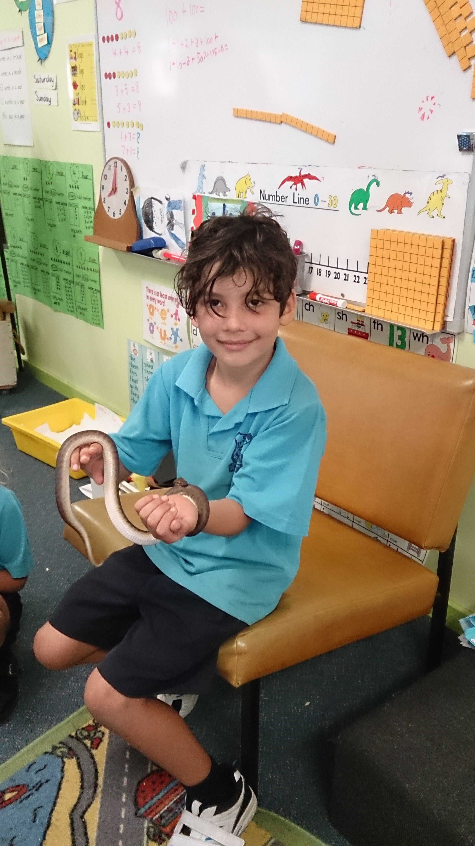

**Uniform shop**

**The Uniform Shop is open on Monday mornings 8.45 to 9.15am. Should you be unable to attend the Uniform Shop during these hours, order forms are available at the school office.**

**Upcoming Events**

Wed 3 December Yr 7 2015 to Toormina High School

Wed 3 December Indigenous Oral Health Day, Toormina PS

Thurs 4 December String Ensemble – Choir at RSL 12:45pm

Fri 5 December Full Band – String Ensemble assembly – Mayor attending

Mon 8 December Presentation Night (Band/Choir)

Mon 8 December Dress rehearsal for Concert

Tues 9 December Parent Helper morning tea at 10:55

Wed 10 December Yr 7 2015 Blue Class Orientation

Wed 10 December Concert Night

Thurs 11 December Sawtell Street Party 5:00-8:00pm

Fri 12 December Level O’Day / Reports Out

Mon 15 December Year 6 Farewell

Tues 16 December School Picnic Day

Wed 17 December Talent Quest / Last Day

**Wed 28 January First day for students 2015**

## Community news

**Expression of Interest: Yoga For Kids**

Monday Afternoons 3–4pm at Sawtell Public School Hall.

$10 a session or $100 per term.

Children will be taught by two teachers: a qualified and insured Oki-Yoga Teacher and qualified Primary School Teacher.

*Classes will include*: stretching, partner work, relaxation, laughter and heaps of fun! If you are interested please contact: Victoria Jenkins on 0401 057 671.

*This is my snake Slinky. I brought him into class for news. I took him out of his cage and Mr Cheers held him while all the kids touched him.* ***1GH were excited!*** *Slinky is a children’s python and he is tame. At home I let him crawl around the house. I have to put the cat outside first so she doesn’t eat him. I love Slinky. By Riaz.*

Please visit our website located at [**http://www.sawtell-p.schools.nsw.edu.au**](http://www.sawtell-p.schools.nsw.edu.au) and click on subscribe news at the top right corner of the page to arrange to receive our school newsletter via email.

Please help us to save the planet by subscribing to the weekly edition of our school newsletter.



**SAWTELL PUBLIC SCHOOL NEWSLETTER** **PAGE 2**



**Sawtell Public School**

**Phone – 02 66531666**

**Fax – 02 66582384**

**E-mail address: sawtell-p.school@det.nsw.edu.au**

**Principal: Michael Cheers**

**We’re on the Web!**

**See us at: www.sawtell-p.schools.nsw.edu.au**